Exercise 4

Due:

1. Consider the following file listings. What information does each highlighted fields provide? [4 marks]

a) drwxr-xr-x 5 nargis staff 4096 Feb 02 2022 flower

**A: Location is a directory, user has read, write, and execute permissions. Group has read and execute permissions. Other has read and execute permissions. Directory has 5 links. User name is nargis, group name is staff. Size is 4096 bytes. Date created is 2022/02/02. Name of the directory is “flower”.**

b) -rw------- 1 nargis staff 2495 Feb 02 2022 food.txt

**A: Location is a file. User has read and write permissions. Group and other has no permissions. File has 1 link. Name of user is nargis, group name is staff. Size of file is 2495 bytes. Date created is 2022/02/02. Name of file is “food.txt”.**

2. Assume you are under your home directory. Explain what would be the result of issuing the following command? [3 marks]

ls -l a?.txt | sort -r | tail -3 > sortedscript.txt

**A: Shows the long-form detailed list of all files that start with “a”, followed by any character, and ends with “.txt”. The contents will be sorted in reverse order. Then, only the bottom 3 lines of the list will be displayed. Finally, the results of the command will make up the contents of a file called “sortedscript.txt”.**

6. In this question you will use the many file-processing tools you’ve learned1. **Write the command for each of the following questions.**

a. Create a file called **vendors.txt** consisting of two colon-separated fields: the vendor number and vendor name: [1 marks]

**1201:Cromwell Interiors**

**1221:Design Extras Inc.**

**1320:Piedmont Plastics Inc**

**1340:Morgan Catering Service Ltd.**

**1350:Pullman Elevators**

**1360:Johnson Office Products**

**A: cat > vendors.txt**

**1201:Cromwell Interiors**

**1221:Design Extras Inc.**

**1320:Piedmont Plastics Inc**

**1340:Morgan Catering Service Ltd.**

**1350:Pullman Elevators**

**1360:Johnson Office Products**

b. Create another file called **products.txt** consisting of three colon-separated fields: the

product number, the product description, and the vendor number: [1 marks]

**S0107:Lobby Furniture:1201**

**S0109: Ballroom Specialties:1221**

**S0110:Poolside Carts:1320**

**S0130:Formal Dining Specials:1340**

**S0201:Reservation Logs:1410**

**A: cat> products.txt**

**S0107:Lobby Furniture:1201**

**S0109: Ballroom Specialties:1221**

**S0110:Poolside Carts:1320**

**S0130:Formal Dining Specials:1340**

**S0201:Reservation Logs:1410**

c. Use the cut, paste, and sort commands as follows to create a single-example vendor report: (write command for each of the following steps) [11 marks]

1. Use the cut command to extract product descriptions and vendor numbers from

the products file and store them in separate files called p1 and p2.

**A: cut -d":" -f2 products.txt > p1**

**A:cut -d":" -f3 products.txt > p2**

1. Extract vendor number and vendor names from the vendors file and store them in   
    separate files called v1 and v2.

**A: cut -d":" -f1 vendors.txt > v1**

**cut -d":" -f2 vendors.txt > v2**

1. Use the paste command to combine v1 and v2, save in v3

**A: paste v1 v2 > v3**

1. Use the paste command to combine p1 and p2,save in p3

**A: paste p1 p2 > p3**

1. Sort and merge the v3 and p3 files using the sort command and send their output

to the vrep file (which is the report). Write the command and also take a

screenshot of this output and add here.

**A:**

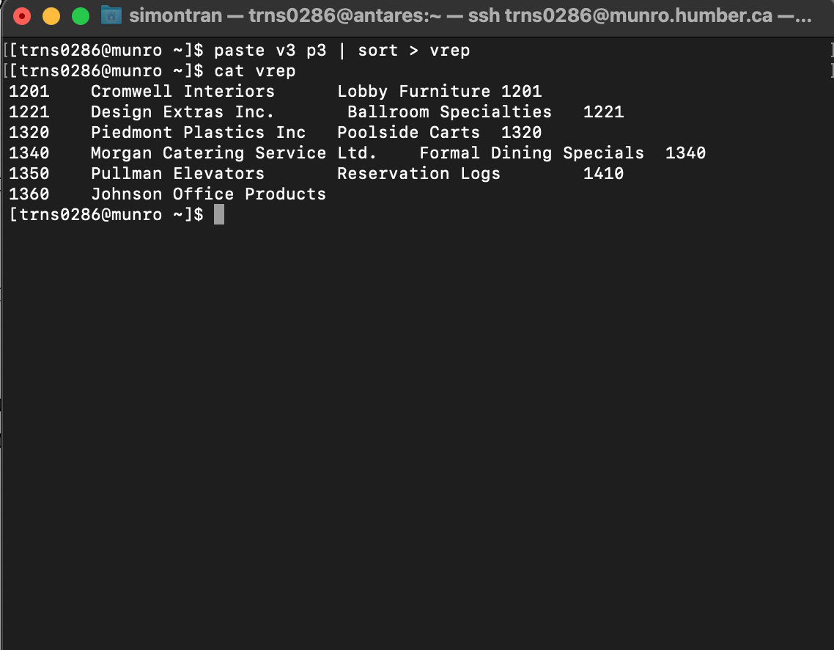

1This last exercise (exercise 6) is from: **Palmer, Michael J. *Guide to UNIX using Linux*. 4th ed. Boston, MA: Course Technology, 2008. Web.**